CSCE 5222 Feature Engineering — Project Report
Gabor Filter Bank Features for Real vs Altered Fingerprint Classification (SOCOFing)

Group 7: Amir Naderian, Alireza Mohammadshafie

1)Problem Statement

We evaluate whether a compact Gabor filter‑bank representation can reliably distinguish authentic (“Real”) from tampered (“Altered”) fingerprints in the SOCOFing dataset. Because fingerprints are composed of oriented ridge‑valley textures, orientation‑ and frequency‑selective Gabor filters are a natural choice for feature extraction. A robust Real‑vs‑Altered detector is important for security (spoof and identity‑fraud prevention), operational quality control during enrollment/verification, and forensic triage. Our goal is an accurate, lightweight solution—faster and easier to deploy than heavy deep models—by summarizing Gabor responses into a small feature vector and classifying with standard learners.
2) Data
- Dataset: SOCOFing (fingerprint images
- Classes: Real (authentic prints) and Altered (includes Easy/Medium/Hard subfolders).
- Counts detected:
- Real: 6000 images
- Altered: 49270 images
- Total: 55270 images
- Preprocessing: convert to grayscale (handling RGB/RGBA/single-channel), resize to 128×128 for consistency.
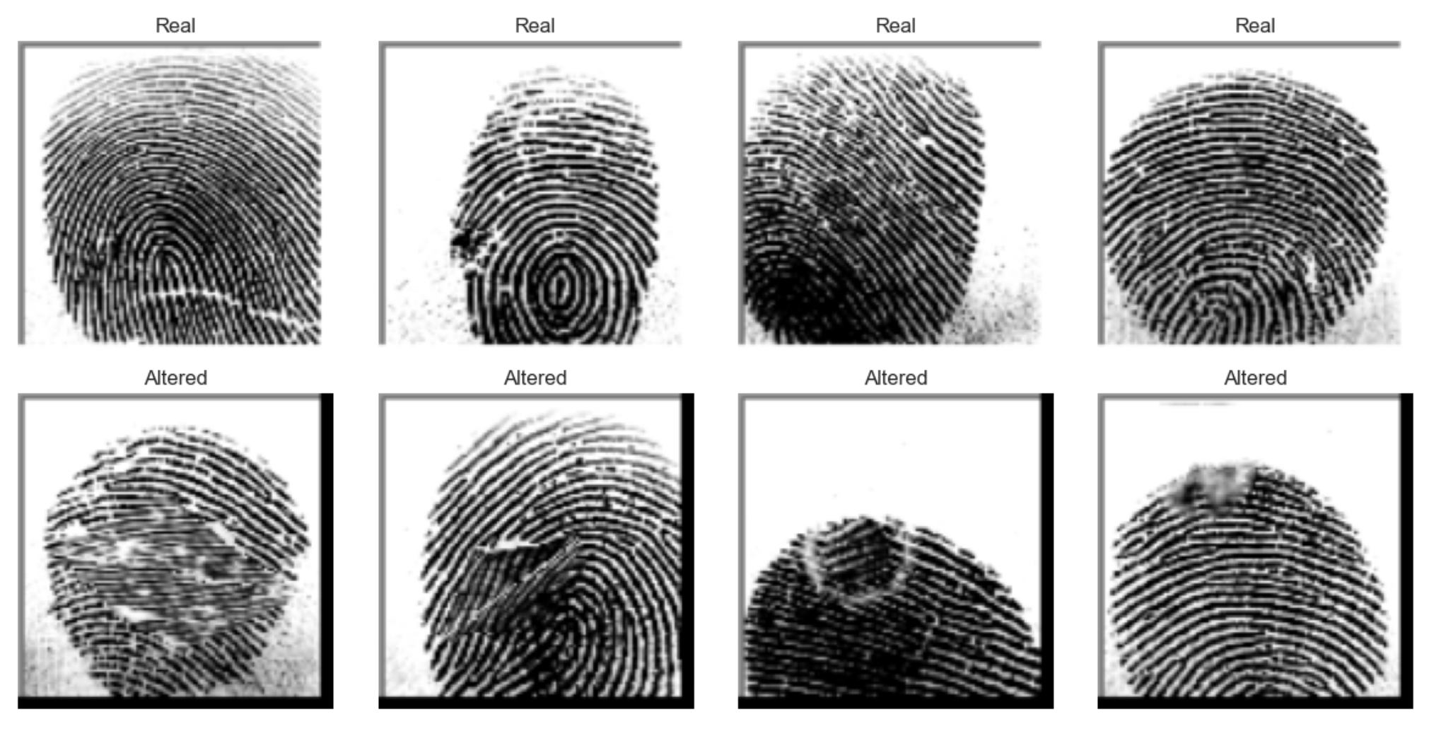

3) Method
3.1 Preprocessing
- Read image
- Convert to grayscale
- Resize to 128×128 (anti-aliased, reflect mode)
- Normalize to [0, 1]

3.2 Gabor Filter Bank and Features
- Orientations (degrees): 0, 45, 90, 135, 180
- Frequencies: 0.1, 0.2, 0.3
- For each (orientation, frequency) pair: compute complex Gabor response; use magnitude; summarize with mean and standard deviation.
- Final feature vector per image: 2 × (5 orientations) × (3 frequencies) = 30 features.

3.3 Splitting, Scaling, and Models
- Split: 20% test; 20% validation from the remaining pool (stratified).
- Train: 33162 samples; Val: 11054; Test: 11054
- Scaling: StandardScaler fit on train features; applied to val/test.
- Classifiers:
- SVM (RBF), class_weight=balanced
- Grid: C ∈ {0.1, 1, 10, 100}; gamma ∈ {scale, 0.01, 0.001}
- CV: Stratified 5-fold
- k-NN
- Grid: n_neighbors ∈ {3, 5, 7, 9}; metric ∈ {euclidean, manhattan}
- CV: Stratified 5-fold

4) Evaluation
- Metrics: Accuracy and Precision (Altered treated as positive class).
- Confusion matrices and classification reports generated on the test set.

5) Results
